**PRACTICAL CURRICULUM**

ACT is uniquely designed for ASEAN English teachers who are not first-language speakers. Most other TESOL certification courses are designed for first-language speakers. Such courses can concentrate heavily on teaching methods, and many incorporate abstract linguistic theories or constructivist philosophy.

ACT, on the other hand, aims to convey teaching methods by way of improving teachers’ own English. For example, a text about teaching methods will be followed by comprehension questions and vocabulary exercises.

Modules on preparing students for TOEFL or IELTS are, in addition, preparation for the teachers themselves, who may be planning to take the TOEFL.

A typical two-hour lesson comprises:

* A 1-2 page reading text
* 4 comprehension questions on the text
* Vocabulary exercises on 10 words in the text
* Viewing a 5-10 minute Youtube Video
* 4 short-answer questions on the video
* 4 Internet Search questions.

These exercises help teachers improve their own

* Reading comprehension
* Vocabulary
* Listening
* Writing

**Twelve Modules**: Each module comprises five two hour lessons, which can be done at any time, in any order.

Teaching Reading 10 hours

Teaching Writing 10

Teaching Grammar 10

Teaching Speaking/listening 10

Teaching TOEFL preparation 10

Teaching IELTS/Duolingo 10

Teaching idioms 10

Slideshow presentation tips 10

Teaching online 10

Using songs and poems 10

Lesson Plans 10

Assessment 10

Instead of the abstract theoretical courses of many TESOL programs, ACT offers practical tips for English teachers, such as

* Tips on better PowerPoint presentations
* Tips on online teaching
* Use of songs, poems, and

Christmas carols

* Better lesson plans
* Tips on assessment

ACT is proud to openly display its curriculum, course material, and staff qualifications. Our core staff all have Master’s degrees or PhDs and years of experience in ASEAN countries. We believe that our credentials speak for themselves, and do not require a TESOL accreditation agency (many of which are themselves bogus) to inform the public about the quality of ACT.

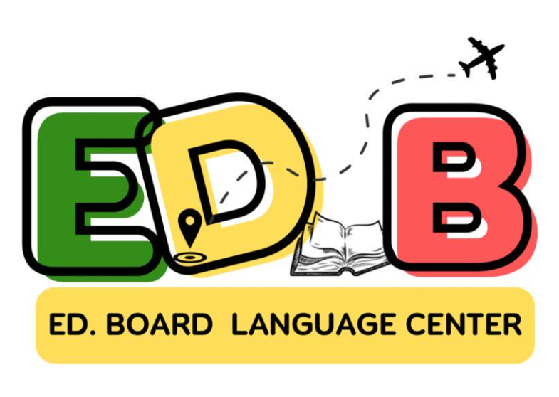

ACT is affiliated with Ed.Board Language Center, located in Battambang, Cambodia. EDB teaches English language at many levels, but specializes in IELTS preparation and study-abroad services. EDB is fully recognized and accredited by the Cambodian Ministry of Education, Youth and Sports, and is authorized to offer English language instruction in many forms, including online platforms.

Courses offered by ACT, normally given online, may also be taken in classrooms at EDB, or as blended courses -- partly online and partly in-class. Diplomas obtained in this manner will awarded in the name of both ACT and EDB.

**ASEAN CERTIFICATE IN TEFL**

(for non-first-language teachers)



120 hours

(12 Modules)

$40/module

$400 for entire program.

Work whenever you want

No deadlines

Certificates issued for completion of

each module and for entire program.